Low Level Design

Books Recommendation System

|  |  |
| --- | --- |
| Written By | DarshanKumarR |
| Document Version | 0.1 |
| Last Revised Date | 29-09-2023 |

 Contents

[Introduction        1](https://docs.google.com/document/d/11ZsH8kpfHudKxEpP882RrH1Ay4Ax44Sf/edit" \l "heading=h.gjdgxs)

[What is Low-Level design document?        1](https://docs.google.com/document/d/11ZsH8kpfHudKxEpP882RrH1Ay4Ax44Sf/edit" \l "heading=h.30j0zll)

[Scope        1](https://docs.google.com/document/d/11ZsH8kpfHudKxEpP882RrH1Ay4Ax44Sf/edit" \l "heading=h.1fob9te)

[Architecture        2](https://docs.google.com/document/d/11ZsH8kpfHudKxEpP882RrH1Ay4Ax44Sf/edit" \l "heading=h.3znysh7)

[Architecture Description        3](https://docs.google.com/document/d/11ZsH8kpfHudKxEpP882RrH1Ay4Ax44Sf/edit" \l "heading=h.2et92p0)

[Data Description        3](https://docs.google.com/document/d/11ZsH8kpfHudKxEpP882RrH1Ay4Ax44Sf/edit" \l "heading=h.tyjcwt)

[Web Scrapping        3](https://docs.google.com/document/d/11ZsH8kpfHudKxEpP882RrH1Ay4Ax44Sf/edit" \l "heading=h.3dy6vkm)

[Data Transformation        3](https://docs.google.com/document/d/11ZsH8kpfHudKxEpP882RrH1Ay4Ax44Sf/edit" \l "heading=h.1t3h5sf)

[Data Insertion into Database        3](https://docs.google.com/document/d/11ZsH8kpfHudKxEpP882RrH1Ay4Ax44Sf/edit" \l "heading=h.4d34og8)

[Export Data from Database        3](https://docs.google.com/document/d/11ZsH8kpfHudKxEpP882RrH1Ay4Ax44Sf/edit" \l "heading=h.2s8eyo1)

[Data Pre-processing        3](https://docs.google.com/document/d/11ZsH8kpfHudKxEpP882RrH1Ay4Ax44Sf/edit" \l "heading=h.17dp8vu)

[Data Clustering        3](https://docs.google.com/document/d/11ZsH8kpfHudKxEpP882RrH1Ay4Ax44Sf/edit" \l "heading=h.3rdcrjn)

[Model Building        4](https://docs.google.com/document/d/11ZsH8kpfHudKxEpP882RrH1Ay4Ax44Sf/edit" \l "heading=h.26in1rg)

[Data from User        4](https://docs.google.com/document/d/11ZsH8kpfHudKxEpP882RrH1Ay4Ax44Sf/edit" \l "heading=h.lnxbz9)

[Data Validation        4](https://docs.google.com/document/d/11ZsH8kpfHudKxEpP882RrH1Ay4Ax44Sf/edit" \l "heading=h.35nkun2)

[User Data Inserting into Database        4](https://docs.google.com/document/d/11ZsH8kpfHudKxEpP882RrH1Ay4Ax44Sf/edit" \l "heading=h.1ksv4uv)

[Data Clustering        4](https://docs.google.com/document/d/11ZsH8kpfHudKxEpP882RrH1Ay4Ax44Sf/edit" \l "heading=h.44sinio)

[Model Call for Specific Cluster        4](https://docs.google.com/document/d/11ZsH8kpfHudKxEpP882RrH1Ay4Ax44Sf/edit" \l "heading=h.2jxsxqh)

[Recipe Recommendation & Saving Output in Database        4](https://docs.google.com/document/d/11ZsH8kpfHudKxEpP882RrH1Ay4Ax44Sf/edit" \l "heading=h.z337ya)

[Deployment        4](https://docs.google.com/document/d/11ZsH8kpfHudKxEpP882RrH1Ay4Ax44Sf/edit" \l "heading=h.3j2qqm3)

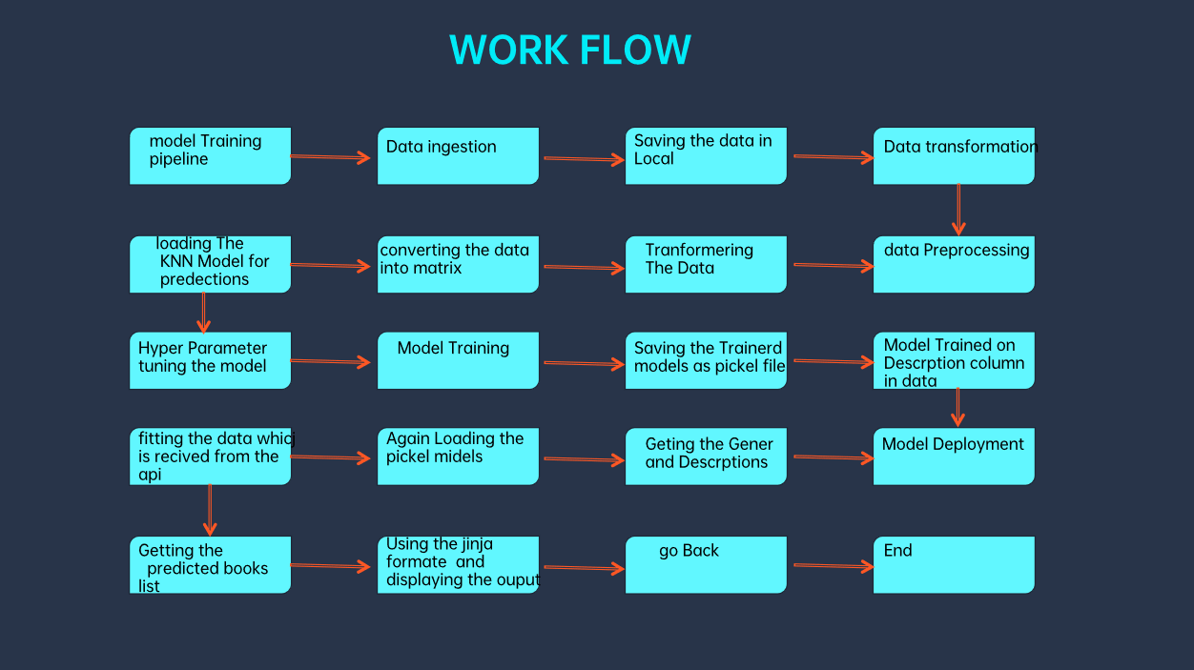

Introduction:

The introduction provides an overview of the Low-Level Design Document (LLD) for a recipe recommendation system. This document outlines the detailed design aspects of the system, including its architecture, data processing stages, and deployment strategy.

What is Low-Level Design Document?

A Low-Level Design Document (LLD) is a comprehensive description of how a software system or application will be implemented. It details the system's architecture, modules, components, data flow, and interaction between components. In the context of this recipe recommendation system, the LLD outlines the step-by-step design and functionality of each component.

Scope:

The scope of the recipe recommendation system includes web scraping recipe data, transforming and preprocessing the data, clustering similar recipes, building recommendation models, collecting user data, validating and processing user input, and deploying the system for end-users. The system aims to provide personalized recipe recommendations based on user preferences.

Architecture:

The system architecture involves components for web scraping, data transformation, database operations, data validation, clustering, recommendation model building, user interaction, and deployment. These components work cohesively to provide a seamless recipe recommendation experience.

Architecture Description:

The architecture description outlines the purpose and functionality of each component within the system. It defines how data flows between components and how they collaborate to achieve the overall goal of recommending recipes to users.

Data Description:

Data for the system includes recipe details obtained through web scraping. These details typically include ingredients, preparation steps, cooking time, and cuisine type. User data, such as preferences and interaction history, is also considered for personalized recommendations.

Web Scraping:

Web scraping is the process of extracting recipe data from websites. It involves fetching HTML content, parsing relevant information, and storing it for further processing.

Data Transformation:

Data transformation includes cleaning and structuring scraped data into a consistent format. This stage ensures uniformity in the dataset, making it suitable for analysis and modeling.

Data Insertion into Database:

Cleaned data is inserted into a database for storage and easy retrieval. A database management system organizes the data, making it accessible for various operations.

Export Data from Database:

Data can be exported from the database for analysis or model training purposes. Exported data serves as the basis for building recommendation models.

Data Pre-processing:

Data pre-processing involves tasks like removing duplicates, handling missing values, and normalizing data. It prepares the dataset for clustering and model building.

Data Clustering:

Clustering groups similar recipes together based on features such as ingredients and cuisine. It enables the system to understand recipe patterns and user preferences.

Model Building:

Machine learning models are built using clustered data. These models learn patterns and correlations in the data, facilitating accurate recipe recommendations.

Data from User:

User data includes preferences, dietary restrictions, and feedback. This data is collected to enhance the personalization of recipe recommendations.

Data Validation:

User input is validated to ensure it aligns with the system's requirements. Invalid or inconsistent data is flagged for correction.

User Data Inserting into Database:

Validated user data is stored in the database. This data forms the basis for user-specific recommendations and interactions.

Model Call for Specific Cluster:

When a user interacts with the system, the appropriate model corresponding to their cluster is called. This ensures that recommendations are tailored to their recipe preferences.

Recipe Recommendation & Saving Output in Database:

The system recommends recipes to users based on their cluster-specific model. Recommended recipes can be saved in the database for future reference.

Deployment:

The system is deployed to a production environment, making it accessible to users. Deployment involves configuring servers, setting up databases, and ensuring the system's availability and performance.